

3CPM EGGSAS© Tools CD

1 Introduction and Overview 1
2 Starting the CD 2
3 The 3CPM Database Tools Menu 3
4 The 3CPM Database Tools 3
4.1 The Orphan File Recovery Program 3
4.1.1 Dealing With Correctable File Errors 5
4.1.2 Finishing the Program 5
4.2 The Data File Viewer Program 6
4.2.1 Starting the Data File Viewer Program 6
4.2.2 The Data File Viewer Selection Screen 6
The Data File Viewer Selection Screen 6
4.2.3 Selecting the Data File 7
The Patient Name in this screen shows either the patient name, or a research Reference Number that was recorded. This is determined by the checkbox that is checked above. 7
4.2.4 Example of a Bad Data File 8

3CPM EGGSAS© Tools CD

Introduction and Overview
The 3CPM Company’s Tools CD is a menu driven CD containing two maintenance tools. These tools can be used to view the basic contents of a patient file, and to reconnect patient files that have been accidentally disconnected from the database. The programs on this CD do not have to be installed on the computer, they are run from the menu on the CD, and they do not need to install or leave any files on the serviced computer.

Starting the CD
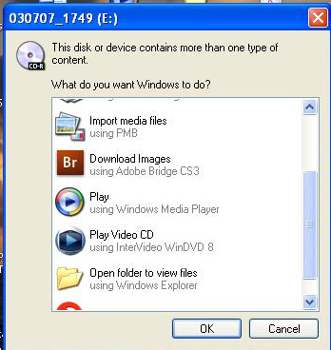
Insert the CD into the player on the computer with the label facing up. If the Autostart function on the computer is enabled the tools menu will appear. If the computer does not start the Tools Menu after the CD is in the computer you will have to do one of two things:

- The following window will appear:
  - If this window appears, select the option “Open folder to view files” that is displayed at the bottom of this image and has a picture of an open file folder as an icon
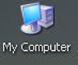
- If this window does not appear and the Tools Menu does not appear, double click the My Computer icon either on the desktop or in the start menu of Windows XP

Both of these choices will display the contents of the CD.

The contents of the CD will look like the following

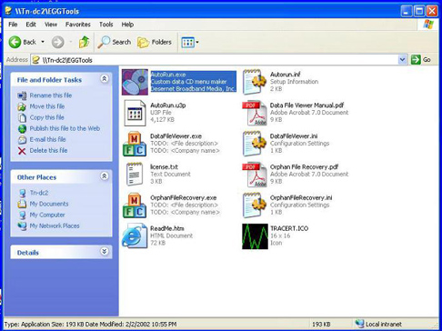
To start the 3CPM Tools Menu from here, double click the RED icon that is highlighted in blue in this picture. The name of the program is “Autorun.exe”.

This will start the 3CPM Tools Menu. Once the menu is started you can minimize or close this window.

Contents of the 3CPM Tools CD

The 3CPM Database Tools Menu
This is the 3CPM Database Tools Menu. It allows you to open a copy of this instruction manual, run both the 3CPM Tools, Browse the CD, or Exit, closing the 3CPM Database Tools Menu.

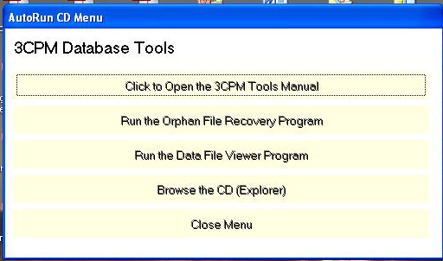

3CPM Database Tools Menu

You may find it useful to select the “Click to Open the 3CPM Tools Manual” so a copy of the instructions can open on the computer for easy access.

The 3CPM Database Tools
There are two maintenance and repair tools included, and are listed as the second and third option on the menu. These tools allow the viewing and recovery of “orphaned patient files”. These are files from studies that exist in the 3CPM folder on the computer, but will not appear or open from within the 3CPM EGG program itself.

The Orphan File Recovery Program
This tool is used when you have done a study and you can see in the C:/3CPM folder that a patient file for that study (Patient Name.egg – All patient files have a .egg ending.) exists, but when you open the 3CPM EGG program the patient name does not appear in your list for selection. It may also appear but not open correctly. Both of these problems are due to the file not matching the data in the 3CPM EGG database.

- Once selected, the following window will appear. The program will automatically compare all the patient files with the database and within a few seconds will display all the patient files that are not correctly attached to the database and will not open correctly:

The three columns show the following:

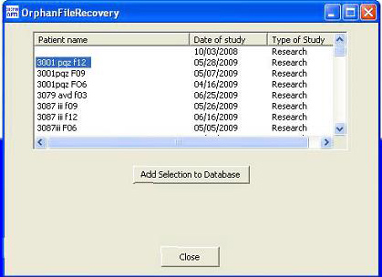
- Patient name or Research reference number, should the study be a research patient and no patient name is used.

- Date of study. This shows when the actual test was done. NOTE: if a patient name or reference number appears more than once in the list you will see different study dates for each listing. This means that more than one study has been done for this patient and that more than one study has been disconnected, or “orphaned” from the program.

- Type of Study. This is the type of study that was done, like a Research or a Waterload study

Select Study Screen

- Select a file by clicking on the Patient name as displayed by the blue surrounding the selected name above.

- Click the Add Selection to Database button. This will present you with the following window:

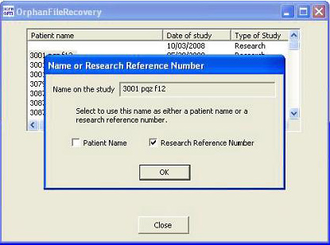

This screen displays the name on the study, and shows whether the program thinks the name is really a Patient Name, or a Research Reference Number. At this time if the wrong box is checked you may change the type of name by selecting the correct check box.

Once everything in this window is correct you may click the “OK” button

Name or Research Reference Number Selection

- When the file is correctly added back into the program the following window will appear:
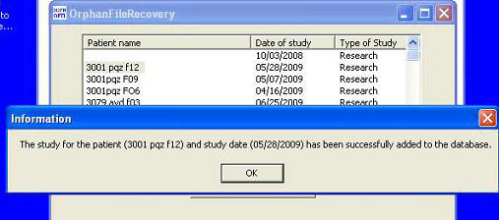

Successful Addition of the file to the database

Once the “OK” button is clicked, the information box will disappear and the selected patient file will be removed from the list. To restore another file repeat steps two through four.

Dealing With Correctable File Errors
If the recovery program finds that data necessary for the orphaned file to function is missing, the following warning will appear:

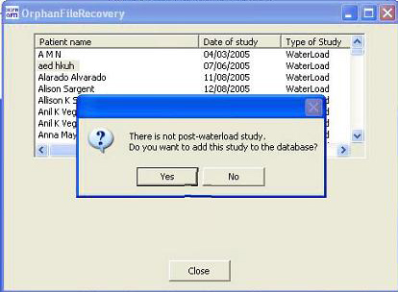

In this case the baseline recording was done but the program was stopped before the actual study was done, or the study data in the file is missing. These files are usually of no use to the program and in most cases you will select “No” and further evaluate the file using the Data File Viewer program to verify the file. The Data File Viewer program’s instructions for use are covered in this manual starting with Chapter 4.2.

Finishing the Program
When you have recovered all the files you wish to recover, Click the “Close” button at the bottom of the window. The program will close and take you back to the Main Menu. Open the 3CPM EGG program, locate the recovered patient(s), and open them to make sure the study was recovered. If you have nothing more to view or recover, click the “Close Menu” button in the 3CPM Tools Menu and remove the CD.

The Data File Viewer Program
The Data File Viewer Program is more of a trouble shooter than a fixer. It’s meant to just display the contents of a data file without any knowledge of a database. It could be helpful if someone thinks a particular study should be different than what the 3CPM EGG program says it is (e.g. waterload vs research, number of minutes in baseline or study, etc). If the 3CPM EGG program can’t read a study, you could use this program to read the data file. If it can read the data file it could provide the cause of the 3CPM EGG program not reading the study. If it can’t read the data file then the data file is corrupt, and the study can not be recovered using these tools.

Starting the Data File Viewer Program

Select the “Run the Data File Viewer Program” button from the Menu. It is the third choice on the 3CPM Database Tools Menu.

The 3CPM Database Tools Menu

The Data File Viewer Selection Screen
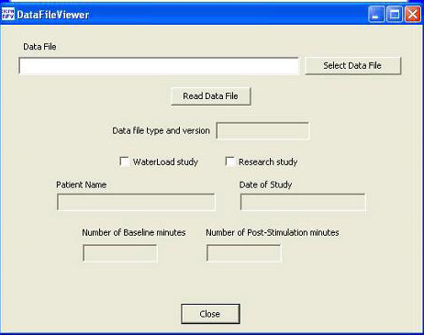

This is the first screen you will see when running this program.

The selection screen opens empty. You must select the data file you wish to view before you can see any data.

The Data File Viewer Selection Screen

Selecting the Data File
When you click the “Select Data File” button, a window listing ALL patient data files that exist in the 3CPM folder will be displayed:

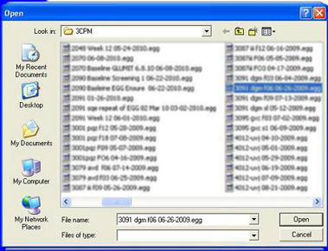

Data File Selection Window

Click on the file you wish to view and click the “Open” button.

- Click the “Read Data File” button

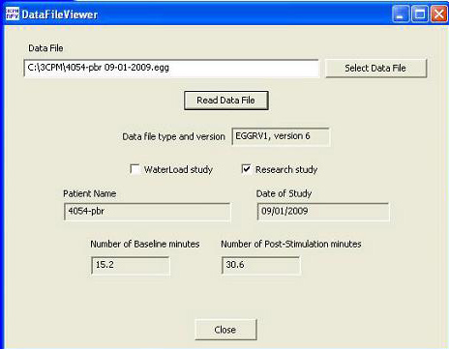
The Data File Viewer will then display the following information from the data file.

The data displayed can be used to make sure the study you selected is a certain type of study, when it was done, which program created the file, and if the study was completed based on the number of Baseline and Post-Stimulation minutes shown.

The Patient Name in this screen shows either the patient name, or a research Reference Number that was recorded. This is determined by the checkbox that is checked above.

Example of a Good Study

Example of a Bad Data File
The problem most often found in bad data files is the lack of recorded Baseline or Post-Stimulation minutes.

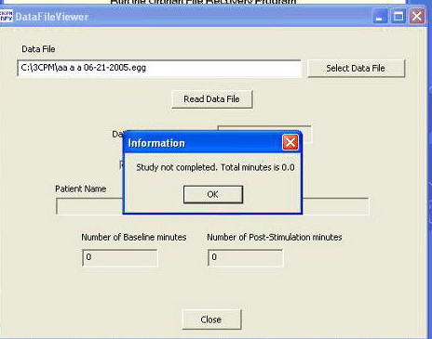
Should this problem be found by the viewer it will show you the following window as a warning:

This can mean the study was cancelled before recording started, was interrupted by mistake or due to a power failure, or was cancelled before both the Baseline and Post-Stimulation recordings were finished.

Study Not Completed

NOTE: Clicking the “OK” button will not close the program. Instead the data the viewer can find will be displayed, and a warning defining the problem will list at the bottom of the window as shown below:
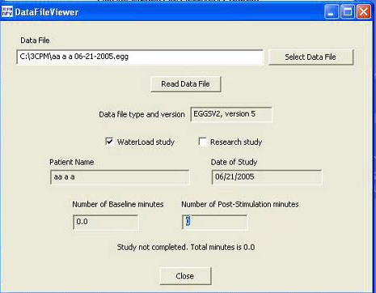

Read File With Warning At Bottom

